http://www.discoveringmadeira.com/funchal.html -- from
http://www.discoveringmadeira.com/discovering-madeira-islands

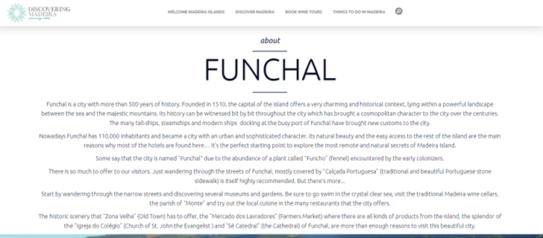

From https://deepmoroccotours.com/4-day-tour-fes-marrakech/
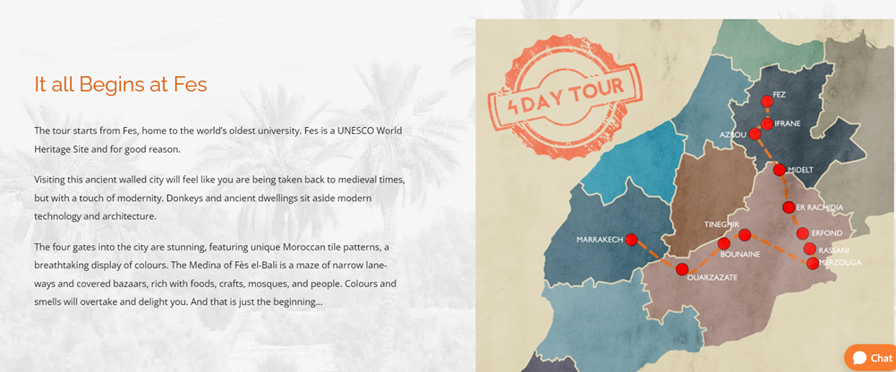

From https://www.barcelonaturisme.com/wv3/en/page/148/catalan-cuisine.html

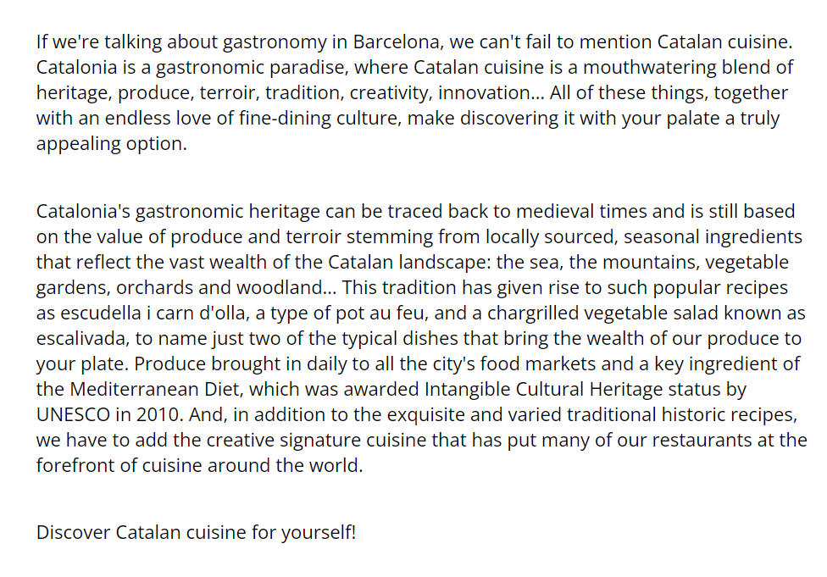

https://www.barcelonaturisme.com/wv3/en/page/4571/10-reasons-to-enjoy-barcelona-s-gastronomic-revolution.html

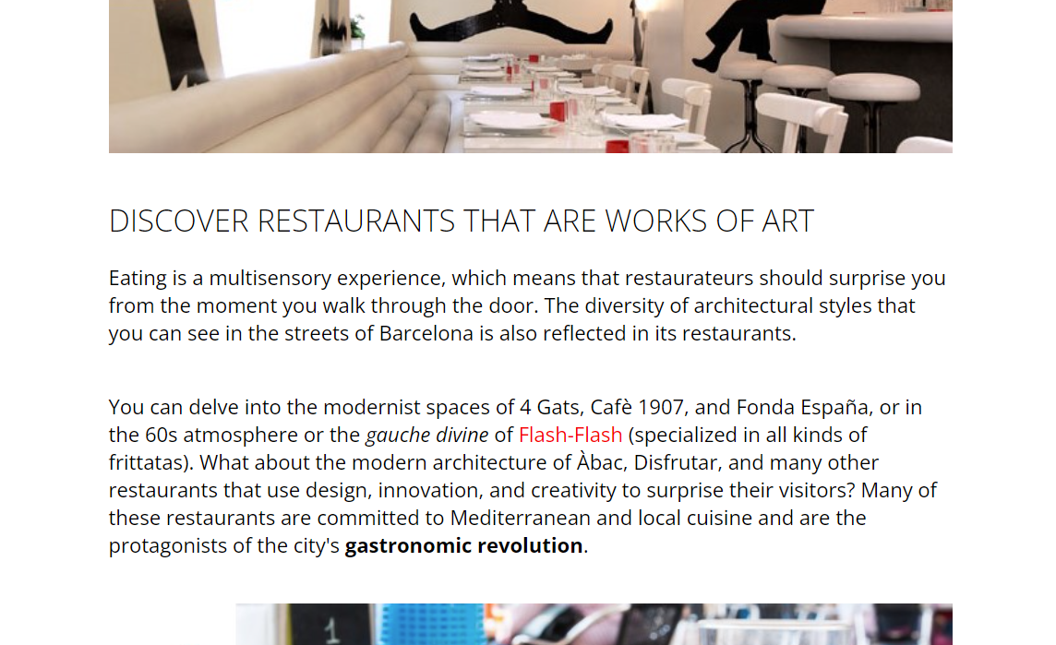
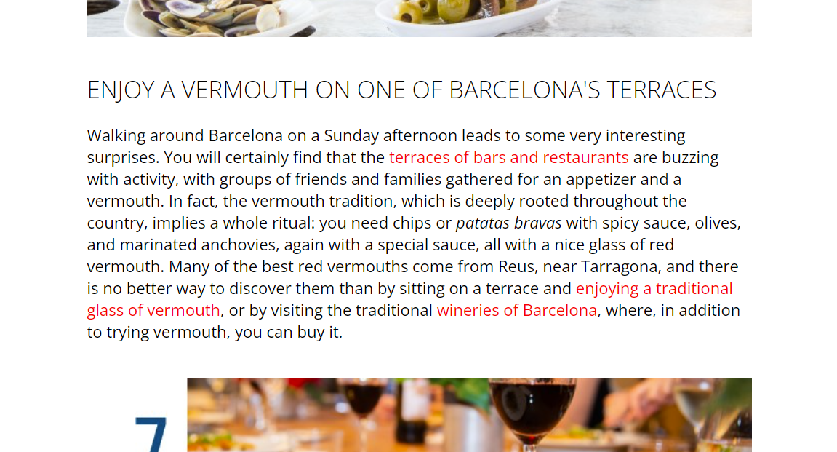

https://www.barcelonaturisme.com/wv3/en/page/3355/barcelona-city-of-the-literature.html

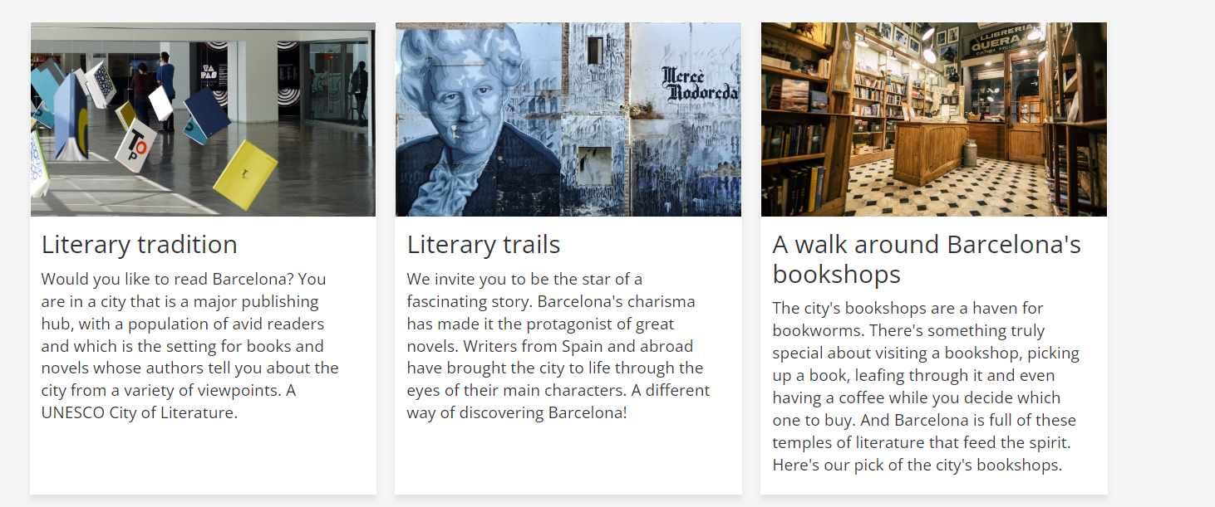

https://www.barcelonaturisme.com/wv3/en/enjoy/165/a-walk-around-barcelona-s-bookshops-.html

https://www.budapestinfo.hu/varkert-bazar
